5D4N HANOI – HALONG – TAMCOC ( OVERNIGHT ON CRUISE)
DAY 1: HANOI – ARRIVAL ( D )
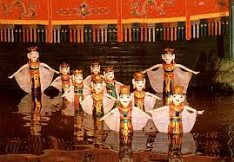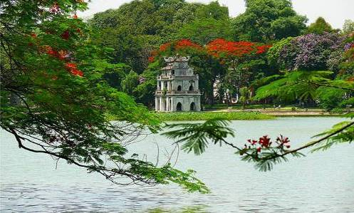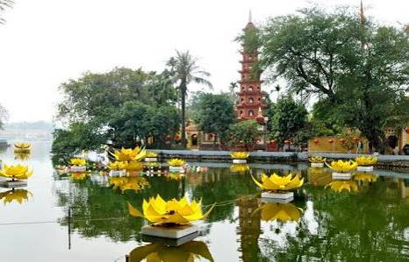
Water Puppet Show Hoan Kiem Lake Tran Quoc Temple
Pick up at airport, transfer to Hanoi downtown to visit the West Lake with Tran Quoc Pagoda, President Palace, Ba Dinh Square, One Pillar Pagoda, shopping at 36 Old Quarters, enjoy the Water Puppet Show. Dinner and overnight in Hanoi.

Meals: 1 Dinner
Accommodation: Overnight in Hanoi.
The distance: Noi Bai Airport – Hanoi Capital: 35km – 45 minutes for transfer

DAY 2: HANOI – HALONG ON CRUISE (B/L/D)
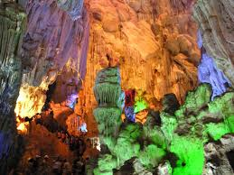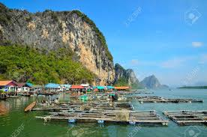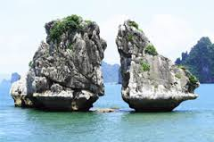
Paradise Grotto Fisherman Village Kissing Chicken Rock
Breakfast at hotel, transfer to Halong Bay - a UNESCO World Heritage site (160km driving one way - 3.5hrs drive). This will be your first opportunity to see some of the rural areas of Vietnam. The drive goes through the Red River delta, so we'll have plenty of chance for taking photo of Vietnamese farmers tilling the vast green paddy field.
12h00 – 12h30: Embark Halong Cruise. Enjoy welcome drink and get a brief introduction about cruise and safety guidelines. Check-in your cabin.
13h15: Have lunch while cruising in the magnificent Bai Tu Long Bay, admiring the fascinating rock and the beautiful of Halong Bay from your cruise.
16h00 Join a guided visit to Stalemate Cave in Ha Long Bay.
17h20: Return to Cruise, enjoy the sunset while relaxing with happy hours from now to dinner time at the bar.
18h00: Enjoy happy hours various drinks on discount. Taking part in a cooking demonstration and food décor with our Chef.
19h00 – 21h00: Dinner is served on cruise restaurant.
21h00 – 22h00: Time of second happy hours to the late night or join squid fishing with the crew, sing karaoke or just laze around or relax in your cabin.

Meals: 1 Breakfast + 1 Lunch + 1 Dinner
Accommodation: Overnight on cruise
The distance: Hanoi – Halong Bay: 160km – 4 hours for transfer & break time on the way.

DAY 3: HALONG AT HOTEL (B/L/D)
06h30 Welcome a new day with amazing dawn on the cruise. Refresh your body & soul by a Tai-chi lesson on sundeck.
07h00 – 08h00: Catch morning view of seascapes with a cup of tea or coffee, have breakfast.
08h00 – 09h00: Climb to the peak of Island for the panoramic views of the bay. Relax on the beach, swim in the emerald water.
09h00: Return to Cruise for freshening up.
09h30: Check out your cabin and continue roaming around the picturesque route toward Bai Tho Mountain near the harbor.
10h30: Have lunch on cruise.
12.00: Arrive back at Ha Long city for disembarkation.
Afternoon visit Hoang Gia Casino. Dinner and overnight in Halong hotel.
Note: The Journey of Cruise is for reference only. It may be changed depending on Cruise

Meals: 1 Breakfast + 1 Lunch + 1 Dinner
Accommodation: Overnight in Halong

DAY 4: HALONG – TAMCOC/TRANGAN - HANOI (B/L/D)
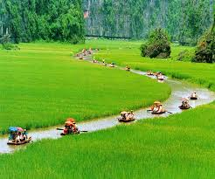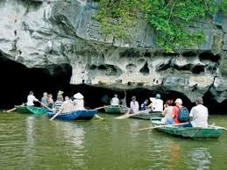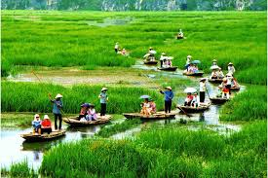
Tamcoc River
Option 1: After breakfast, transfer to NinhBinh province, visit the Bich Dong Temple, lunch at local restaurant, take sampan trip along the stream to visit Tamcoc River - Halong Bay on land, transfer back to Hanoi, visit French Opera House, dinner at local restaurant, overnight in Hanoi.
Option 2: After breakfast, transfer to Trang An - The Tourism Complex in the northern province of Ninh Binh was officially included in the world heritage list on June 23 by the UNESCO’s World Heritage Committee. The eco tourist attraction located in the East of Ninh Binh, with area of 2000 ha, It includes 47 historical vestiges with many mysterious things, with limestone mountains, valleys and underground river systems. Take boat trip to visit cave complex: Sang Cave, Toi Cave, Ba Giot Cave, Nau Ruou in mystery and wildness, see scenery of mountain and rivers Ha Long on land of Ninh Binh. The end of the day, drive back Hanoi, visit French Opera House, dinner at local restaurant, overnight in Hanoi.
Meals: 1 Breakfast + 1 Lunch + 1 Dinner
Accommodation: Overnight in Hanoi
The distance: Hanoi – Ninh Binh: 160km – 4 hours for transfer & break time on the way.

DAY 5: HANOI DEPARTURE (B)
After breakfast, free at leisure then transfer to airport for flight home.

Meals: 1 Breakfast
The distance: Hanoi Capital - Noi Bai Airport : 35km – 45 minutes for transfer.
The ends of program!

SEQUENCE OF ITINERARY SUBJECT TO LOCAL ARRANGEMENT

PRICE INCLUDE:
- Accommodation – as hotel in the list or similar – based on Twin/Double/Triple sharing.
- Tour guide: English or Chinese speaking guide during the tour.
- Daily ABF and meals as mentioned in the program.
- Shows and sightseeing in schedule.
- Transportation by private air-conditioner.
01 bottle ( 500 ml )of drinking water for each pax per day.
- Meals (Vietnamese Food & Chinese Food) as the tour code (B: Breakfast, L: Lunch, D: Dinner) 8-10 USD/meal/pax + one buffet at Sen Tay Ho Restaurant .
- Cruise in Halong ( Sharing cruise on private cabin).
- Boat fees private one in TamCoc/Trangan as mentioned in the program.
PRICE EXCLUDE:
- International / Domestic flight ticket & airport tax (if have).
- Personal expenses: Tel, Fax, Mini Bar, Laundry,etc.
- Personal travel insurance.
- Compulsory Tip for local guide and driver (USD/pax/day)

Group Size | Tips in USD
2 – 4pax | 6
5-7pax | 5
8 - up | 3

- Surcharge with other languages guide.
- Additional Meal will be surcharge 10usd/pax/meal.
- Surcharge at hotel case by case
  - Chinese New Year (TBA).
  - Gala Dinner on X’Mas (24, 25 Dec ) & New Year 31 Dec.

Hotel listed or Similar |  |  | All rates are next in USD/PAX  valid Jan- Dec, 2020
 |  |  | Tour by private car / bus with private guide
HANOI | HALONG CRUISE | HALONG HOTEL | 2 | 3-4 | 5-6 | 7-9 | 10-12 | 13-15 | 15+1 | 20+1 | 25 +1 | 30+1 | Sgl up
Larosa 3*  Pomihoa 3*  First Eden 3*  Thang Long Espana 3*  Adamas 3*  Authentic 3* | Oriental Sail 3*  Swan 3* | Seastar 3*  Golden Bay Ha Long 3*  Sen Hotel 3* | 425 | 371 | 331 | 308 | 301 | 293 | 290 | 281 | 275 | 271 | 175
Thang Long Opera 4*  Chalcedony 4*  May De Ville 4*  Muong Thanh Centre 4*  Kuretakeso 4* | Calypso 4*  Flamigo 4*  Syrena 4* | Galaxy Ha Long 4*  Au Lac 4*  Mithrin 4*  Song Loc 4* | 478 | 423 | 383 | 361 | 355 | 346 | 340 | 331 | 325 | 318 | 223

NOTE

The timing of sightseeing points shall be fixing by local operator due to traffic and weather conditions, however all points must cover unless amendment or cancellation make by clients themselves (Non-refundable for any cancellation that made by clients)

Tour and price are subject to change without notice or incase of deduct number of pax in quoted group.

Small deviations in the tour program are sometimes necessary, depending on weather, road conditions, flight schedules and room availability.

Supplement charge for room rate in peak dates depends on the hotel category used. Compulsory gala dinner on X’mas, New Year’s Eve & Lunar New Year’s Eve to be advised upon booking. Prices for group of 15 persons up in 5 stars hotels sometime requires to re-quote bases on the hotel policy

01 FOC for tour leader based on twin sharing basis include breakfast (domestic air ticket is not applicable).

BUS

Group Size | Kind of Transportation
1-2 pax | 4 seater
3 pax | 7 seater
4-9pax | 16 seater
10-18 pax | 30 seater
19-21 pax | 35 seater
22 – 42 pax | 45 seater

TRAVEL TIPS:

The tour guide will introduce some optional.
1/ Trishaw to visit 36 old quarters 10 USD/1 pax/ 1 trishaw
2/Vietnamese traditional massage in Halong bay: 1h30 minutes including tips: 20 USD/ pax

- Commisstion 10% for tour leader

SHOPPING INFO:

1/ Vietnam local products
2/ Halong duty free jewelry center

- Commision 5% for Tour Leader

Tour request without shopping and no options will be surcharge 10USD/pax

CHILD POLICY

- Infant below 2 years old sharing same room with parents is free of charge.
- Child below 12 yrs old sharing same room with 1 ADL is charged for 90%.
- Child below 12 yrs old with extra bed and sharing same room with parents is charged for 65%.
- Child below 12 yrs old No extra bed & sharing same room with parents is charged for 55%

